Batch:C3 Roll No.: 16010123217

Experiment No. 07

TITLE: Demonstrate the Super Global Variables and File Uploading in PHP

AIM: To understand various file operations and file upload in PHP
____________________________________________________________________
Expected Outcome of Experiment: Process external files in PHP.
________________________________________________________________
Books/ Journals/ Websites referred:

- Official PHP Documentation (https://www.php.net/docs.php)
- W3Schools PHP Tutorial (https://www.w3schools.com/php/)
- GeeksforGeeks PHP File Handling (https://www.geeksforgeeks.org/php-file-handling/)

_____________________________________________________________________

Problem Statement: Description of the application implemented with output:

Develop a PHP application to demonstrate the use of super global variables ($_FILES, $_POST, $_GET) and implement file uploading functionality. Perform basic file operations like open, read, write, append, and delete using PHP.

PHP Basic Concepts Learned With Syntax

Read file
string fread ( resource $handle , int $length )

Write file
int fwrite ( resource $handle , string $string [, int $length ] )

Delete File
bool unlink ( string $filename [, resource $context ] )

Description of the application implemented with output:

<!DOCTYPE html>
<html>

<head>
<title>File Upload in PHP</title>
<link rel="stylesheet" type="text/css" href="styles.css">
</head>

<body>
<h2>Upload a File</h2>
<?php
$host = "localhost";
$user = "root";
$password = "";
$db = "FileUploads";

$conn = mysqli_connect($host, $user, $password, $db);
if (!$conn) {
die("<p class='error'>Connection failed: " . mysqli_connect_error() . "</p>");
}

if (isset($_POST['submit'])) {
$fileName = basename($_FILES["fileToUpload"]["name"]);
$fileType = strtolower(pathinfo($fileName, PATHINFO_EXTENSION));
$fileData = addslashes(file_get_contents($_FILES["fileToUpload"]["tmp_name"]));
$uploadOk = 1;

$checkQuery = "SELECT * FROM files WHERE name='$fileName'";
$checkResult = mysqli_query($conn, $checkQuery);
if (mysqli_num_rows($checkResult) > 0) {
echo "<p class='error'>Sorry, file already exists.</p>";
$uploadOk = 0;
}

if ($_FILES["fileToUpload"]["size"] > 2097152) {
echo "<p class='error'>Sorry, your file is too large.</p>";
$uploadOk = 0;
}

$allowedTypes = array("jpg", "png", "jpeg", "gif", "pdf", "txt");
if (!in_array($fileType, $allowedTypes)) {
echo "<p class='error'>Sorry, only JPG, JPEG, PNG, GIF, PDF, and TXT files are allowed.</p>";
$uploadOk = 0;
}

if ($uploadOk == 1) {
$insertQuery = "INSERT INTO files (name, type, data) VALUES ('$fileName', '$fileType', '$fileData')";
if (mysqli_query($conn, $insertQuery)) {
echo "<p class='success'>The file " . htmlspecialchars($fileName) . " has been uploaded.</p>";
} else {
echo "<p class='error'>Sorry, there was an error uploading your file.</p>";
}
}
}
?>
<form action="" method="post" enctype="multipart/form-data">
Select file to upload:
<input type="file" name="fileToUpload" id="fileToUpload">
<input type="submit" value="Upload File" name="submit">
</form>

<h2>Uploaded Files</h2>
<ul>
<?php
$fetchQuery = "SELECT * FROM files";
$result = mysqli_query($conn, $fetchQuery);
while ($row = mysqli_fetch_assoc($result)) {
echo "<li><a href='view.php?id=" . $row['id'] . "' target='_blank'>" . $row['name'] . "</a></li>";
}
?>
</ul>
</body>

</html>

Description of the application implemented with output:

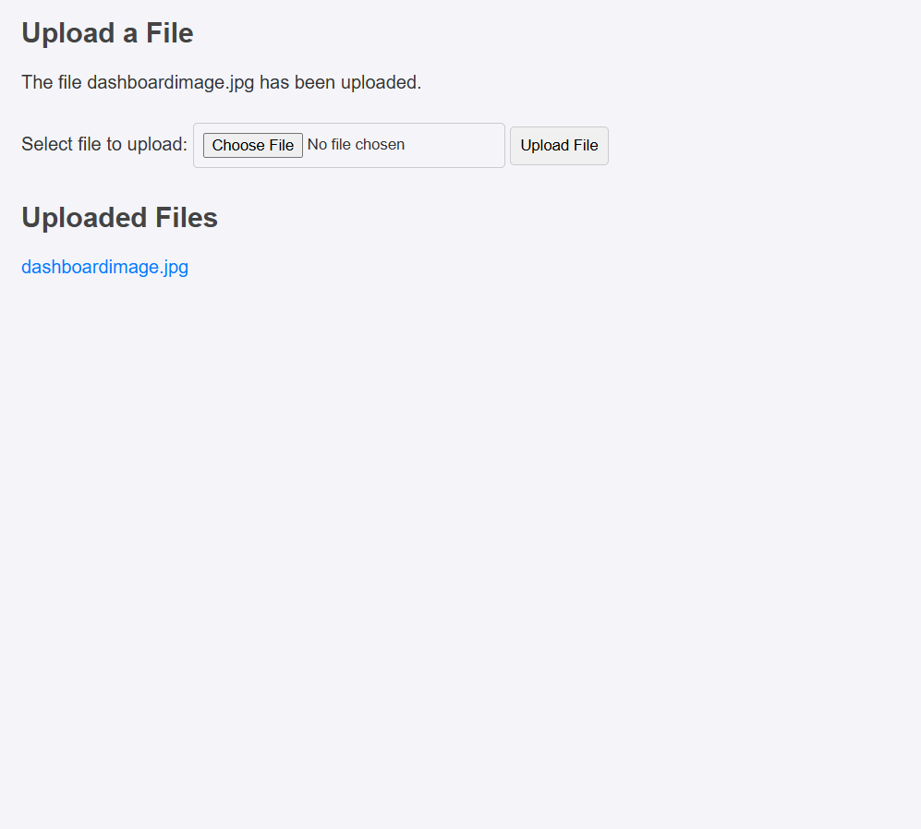
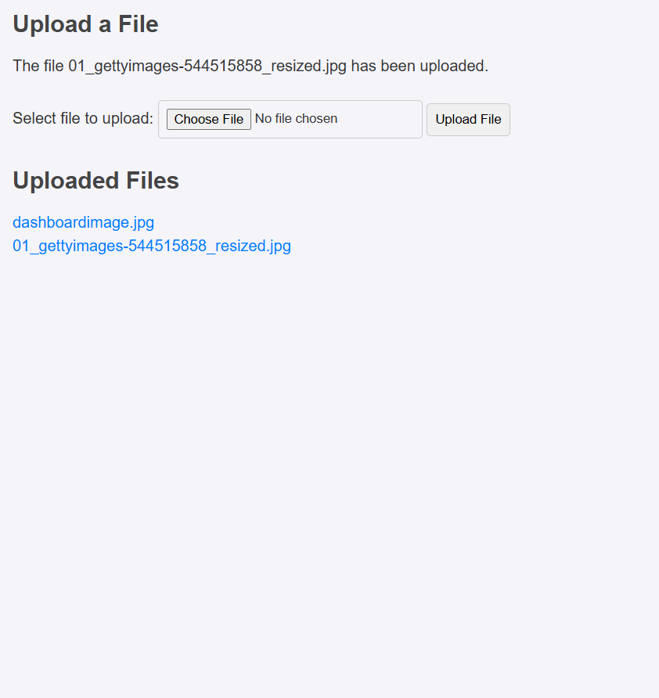

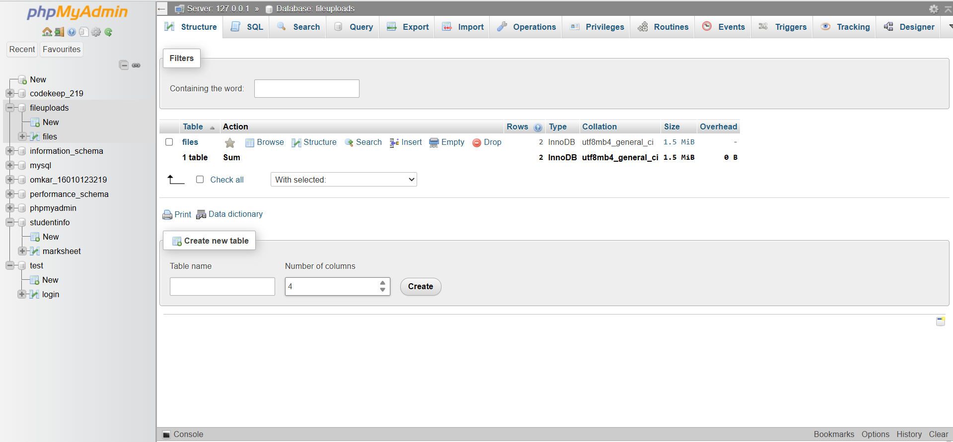

Post Lab Questions:
1. Perform following file operations with respect to problem statement/application:
Open, read and write with various modes, read, write and delete file.
Answer: Code with output screenshots
Read File
<?php
$file = fopen("test.txt", "r");
echo fread($file, filesize("test.txt"));
fclose($file);
?>


Write File
<?php
$file = fopen("test.txt", "w");
fwrite($file, "This is a sample text.");
fclose($file);
?>

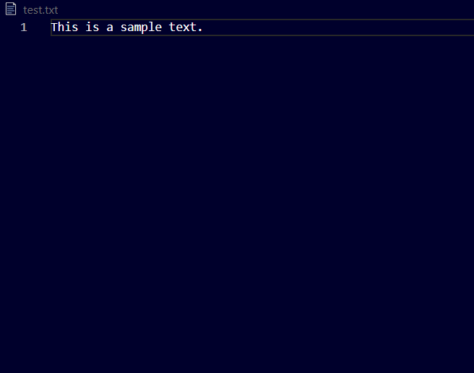
Delete File
<?php
$file_path = "uploads/sample.txt";
if (file_exists($file_path)) {
unlink($file_path);
echo "File deleted successfully.";
} else {
echo "File not found.";
}
?>

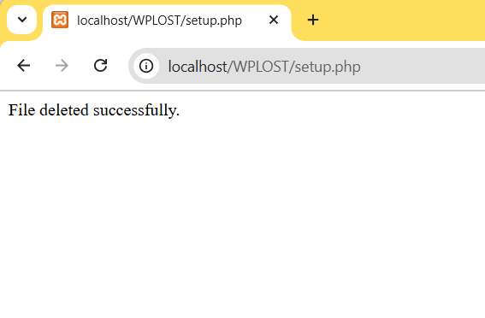
Conclusion
This experiment helped in understanding the working of super global variables and implementing file upload functionality using PHP. Various file operations like open, read, write, append, delete, and download were successfully demonstrated with appropriate output. Additionally, a simple viewer was created to display uploaded files directly in the browser. Buttons were also added to navigate between the upload and view pages for a seamless user experience.

